Table TRANSACTIONS dropped.

Table PRODUCTS dropped.

Table CUSTOMERS dropped.

Table CONTAINS dropped.

Table PRODUCT created.

Table CUSTOMER created.

Table TRANSACTIONS created.

Table TRANSACTION_CONTAINS created.

1 row inserted.

1 row inserted.

1 row inserted.

1 row inserted.

1 row inserted.

1 row inserted.

1 row inserted.

1 row inserted.

1 row inserted.

1 row inserted.

1 row inserted.

1 row inserted.

1 row inserted.

1 row inserted.

1 row inserted.

1 row inserted.

1 row inserted.

1 row inserted.

1 row inserted.

1 row inserted.

1 row inserted.

1 row inserted.

1 row inserted.

1 row inserted.

1 row inserted.

1 row inserted.

1 row inserted.

1 row inserted.

1 row inserted.

1 row inserted.

1 row inserted.

1 row inserted.

1 row inserted.

1 row inserted.

1 row inserted.

1 row inserted.

1 row inserted.

1 row inserted.

1 row inserted.

1 row inserted.

1 row inserted.

1 row inserted.

1 row inserted.

1 row inserted.

1 row inserted.

1 row inserted.

1 row inserted.

1 row inserted.

1 row inserted.

1 row inserted.

1 row inserted.

1 row inserted.

1 row inserted.

1 row inserted.

1 row inserted.

1 row inserted.

1 row inserted.

1 row inserted.

1 row inserted.

1 row inserted.

1 row inserted.

1 row inserted.

1 row inserted.

1 row inserted.

1 row inserted.

1 row inserted.

1 row inserted.

1 row inserted.

1 row inserted.

1 row inserted.

1 row inserted.

1 row inserted.

1 row inserted.

1 row inserted.

1 row inserted.

1 row inserted.

1 row inserted.

1 row inserted.

1 row inserted.

1 row inserted.

>>Query Run In:Query Result

>>Query Run In:Query Result 1

>>Query Run In:Query Result 2

>>Query Run In:Query Result 3

Commit complete.

**CS550: Database**

**Project 1-3**

**1)**

**2)**

**3)**

**4)**

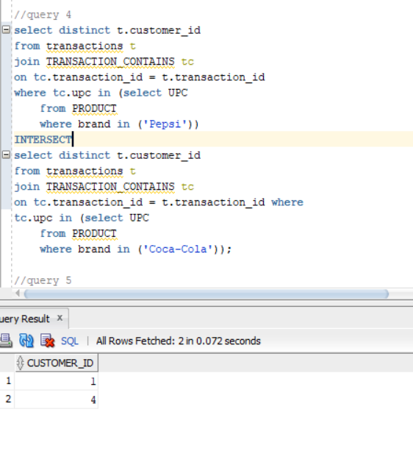

**5)**

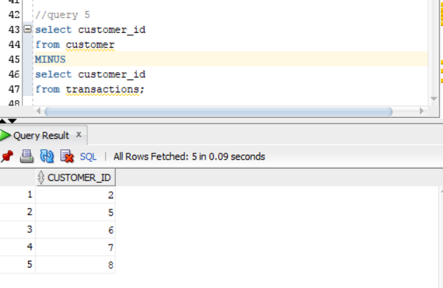

**6)**

**7)**

**8)**

